

Golden Grove Lutheran Vacation Care Program
October Vac Care 2026

Week 1 28th September – 2 October
28th September | 29th September | 30th September | 1st October | 2nd October
Dress up day | Home Fresh cooking | Anstey’s Hill Old Newman nursery | Adelaide Oval Tour | Sensory play day
Home day - $72.75 | Incursion $ 78.30 | Excursion - $84.00 | Excursion - $84.00 | Home day - $72.75
   |      | 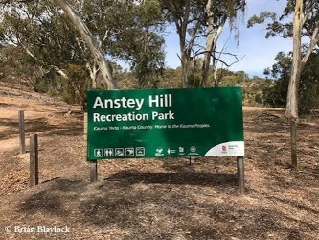  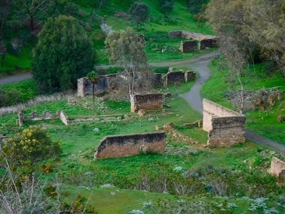 | 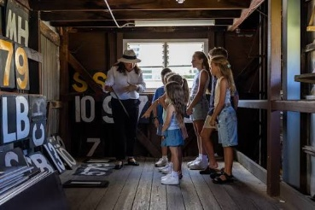     |   
BYO Recess, Lunch & drink bottle  Lunch provided – Chicken Burgers | BYO Recess, Lunch & drink bottle | BYO Recess, Lunch & drink bottle | BYO Recess, Lunch & drink bottle | BYO Recess, Lunch & drink bottle  Lunch provided – Hotdogs
Fruit and Vegetable Snack supplied at around 3pm
Snack supplied around 4pm


Golden Grove Lutheran Vacation Care Program
October Vac Care 2026

Week 2 6th – 9th October
5th October | 6th October | 7th October | 8th October | 9th October
Labour day | Thorndon park playground | Transport day | Adelaide Zoo | Kelly sports – Nerf battle
Labour day | Excursion - $84.00 | Home day - $72.75 | Excursion - $84.00 | Incursion $ 78.30
Public Holiday | 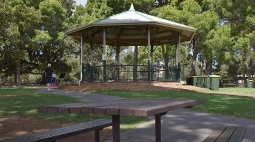  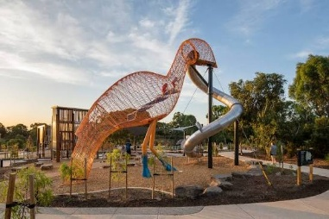  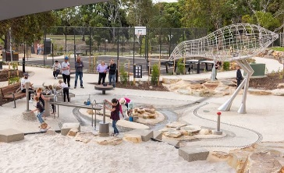 |      |     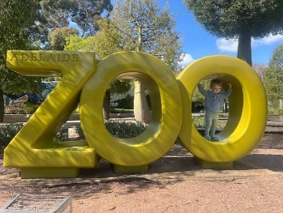 |   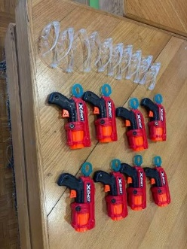
 | BYO Recess, Lunch & drink bottle | BYO Recess, Lunch & drink bottle  Lunch provided – Burrito bowls | BYO Recess, Lunch & drink bottle | BYO Recess, Lunch & drink bottle  Lunch provided – Chicken wraps
Fruit and Vegetable Snack supplied at around 3pm
Snack supplied around 4pm

